

MULTIFUNCTION ROVER
1

Under the Supervision of
Prakash B Metre
Dept of CSE Presidency University

Submitted By

Name | Id
D Sree Bhargav Reddy | 20201CSE0171
M Abhiram Reddy | 20201CSE0116
Arjun Arun | 20201CSE0134
B Sravan Kumar Reddy | 20201CSE0133
Kodidala Babu | 20201CSE0170

Submission Date:

Department of
Computer Science and Engineering

Presidency University

Acknowledgment

This project was completed for the coursework, directed by the Department of Computer Science and Engineering, Presidency University. Our sincere efforts have made us accomplish the task of completing the project. Most importantly, we would like to express our gratitude to our honorable teacher, Prakash B Metre for his advice and valuable comments regarding our project, which led us to the completion of the project. Our thanks and appreciation also goes to our classmates, who encouraged us to complete our project.

Abstract

A remote-controlled rover is any mobile machine controlled by means that are physically not connected with the origin external to the rover.

In this project, we make use of Bluetooth technology and Voice Assistant to control our rover. We do call this a rover as this device which have ultrasonic sensor. The project aims are to design a Bluetooth and voice assistant control Arduino rover and write a program into the Arduino microprocessor. Rover contains an Arduino microcontroller with basic mobility features.

After doing this only we can say that we have been able to create as per our goal described. The device can be controlled by any smart device with android. The major reason for using a Bluetooth-based and voice assistant tech is that we can change the remote anytime – mobile phones, tablets, and laptops and physical barriers like walls or doors do not affect the car controls.

Table of Contents

Chapter | Title | Page
 | Acknowledgment Abstract | 2  3
1 | Introduction  - Background  - Problem Statement  - Project Overview
5
5
5
2 | Literature Review | 6
3 | Methodology  - Tools  - Pin Diagram and Connection  - Source Code  - Flow Chart of Implementation
7
12
13
17
4 | Result and Discussion | 18
5 | Individual Contribution | 19
6 | Conclusion | 20

Chapter-01

  - Background:

Wireless or Bluetooth and voice control rover are developed to make our day-to-day life easy and simpler. Today for striving in this modern era it is necessary to use modern technology to simplify our day-to-day activities. Thousands of people die because of driving vehicles. If it can be remote- controlled, we will be able to save thousands of lives. The drone started a revolution in this regard. Bluetooth-controlled rover or cars can be a revolutionary project for our upcoming future. It can be used for low-range mobile devices, (military Applications where no human intervention will be needed), Assistive devices (like wheelchairs), home automation, etc. It is aimed to bring a huge groundbreaking change in society by overcoming the hurdles we are facing today. Driverless cars are providing mobility to many people who cannot drive which is an added advantage to commuters who wish to use cars on daily basis. Bluetooth and voice control rover or cars are the gadget of the future.

1.2 Problem statement:

Bluetooth and Voice Control rover can be a helping hand for the cripples, or for the ones who want to drive but are unable due to many physical inabilities, where human life is at risk, we can use it from a very distance as it is fully wireless.

1.3 Project Overview:

The main processing unit consists of Arduino UNO to perform specified operations. Arduino UNO board is used as the main microprocessor of the device. It will run and will control the movement of the vehicle through the use of the motor driver who will control the wheels. The Programs are compiled using Arduino IDE and then the sketch is uploaded to the board using a pc and a USB cable. Speed variations can be achieved by making slight changes to the sketch.

It is based on a 6-wheel drive platform integrated with an ultra-sonic sensor to avoid obstacles. The car is upgradable and can replace, upgrade and expand the input sensors and add other functionality by adding other modules.

Chapter-02

Literature Review

Wireless control is one of the most important basic needs for all people all over the world. Bluetooth is one of the most used wireless technologies. A Bluetooth control car is such a car that can be controlled wirelessly using a Bluetooth control system and Arduino. With the combination of Arduino, and Bluetooth we can control many other things, like home Lighting, air conditioners, and many more through our cell phones. The Arduino can also contribute at large to the Smart Home system. Nowadays it has made us easier to convert digital signals into physical movements with such microcontrollers.

Today people are using autonomation in every sector. There are many benefits, for example, it reduces the risk of injury, it is fast, it can work day long, it is reliable, etc. This Bluetooth control car is just an example of autonomation. This type of car is used in law enforcement and military engagements for some the reasons like Hazard exposure which is controlled from a location of relative safety. Such vehicles are used by many police department bomb squads to defuse or detonate explosives.

These vehicles are also used in space exploration, by using such vehicle NASA. ESA and ROSCOSMOS have explored and collected many data from space, the moon, and mars. In recent days giant companies are using remote control vehicles to deliver their products. And Many of the giant factories have their transportation which is remotely controlled.

Here we have connected this 4-wheeler with Arduino and Bluetooth Module/ There is an Android application that is already installed in the remote device. We send our instruction to the vehicle with that application, that application is connected with the module in the vehicle. Bluetooth module transfer that instruction as a signal to the Arduino, and Arduino works with that signal. In the Arduino, we have installed the code which can work with the signals and convert those instructions to the pre-defined signals. Signals were transferred to the motors, and the car started running.

This car does not have advanced features but we can attach any kind of features like line detecting, or obstacle detecting, even though we can attach the camera to the vehicle and watch it with the remote. This one is just a basic prototype of a remote-control car, we can add a lot of advanced features and get an armed/especially capable RC Car.
This project aimed to design an automated vehicle prototype built with Arduino and controlled with software developed on Android that can perform manual or automatic paths. Until now research and analyzing the simulation of experiments shown, it is believed that it is feasible to use the prototype designed for cognitive development, for future users can learn to insert custom paths that can process logic issues and more complex mathematics allowing the prototype to perform the desired movements. Analyzing the financial costs of design, it is believed that it is feasible to construct this type of prototype because it presents a low cost of the components used, particularly if they are chosen in a largescale production. It is worth noting that both the Arduino programming language and the language for Arduino in development are free, not burdening additional costs for the development of the project, pointing out that this applies also to the tools used for development. [1]

Chapter-03

Methodology

3.1 Tools:
- Chassis (Including motors and wheels):

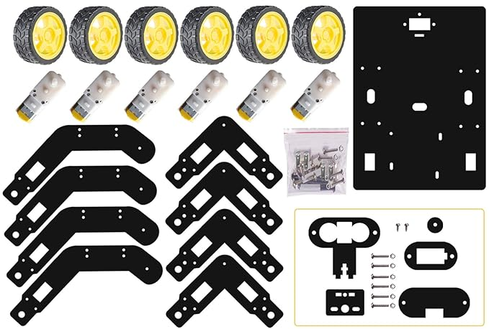

- Arduino Uno:
The Arduino Uno is an open-source microcontroller board based on the Microchip ATmega328P microcontroller and developed by Arduino. cc. The board is equipped with sets of digital and analog input/output pins that may be interfaced with various expansion boards and other circuits.
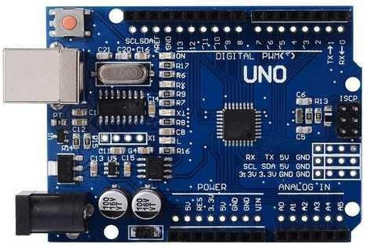

- L293D Motor Drive H-Shield:

The Motor Driver is a module for motors that allows you to control the working speed and direction of two motors simultaneously. This Motor Driver is designed and developed based on L293D IC. L293D is a 16 Pin Motor Driver IC. This is designed to provide bidirectional drive currents at voltages from 5 V to 36 V. Rotation of a motor depends on the enabled pins.
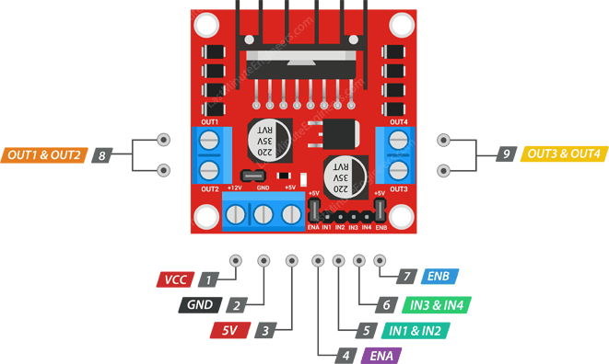
- Jumper Wires:

A jump wire (also known as jumper, jumper wire, DuPont wire) is an electrical wire, or group of them in a cable, with a connector or pin at each end (or sometimes without them – simply "tinned"), which is normally used to interconnect the components of a breadboard or other prototype or test circuit, internally or with other equipment or components, without soldering.
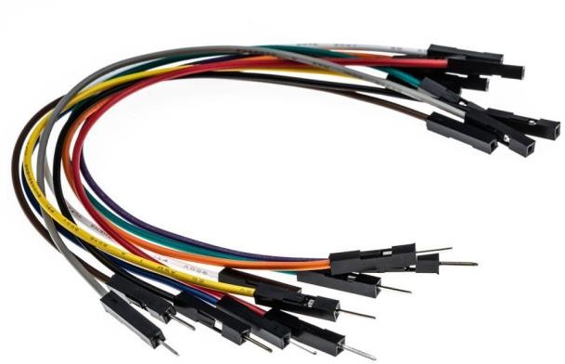
- Battery:

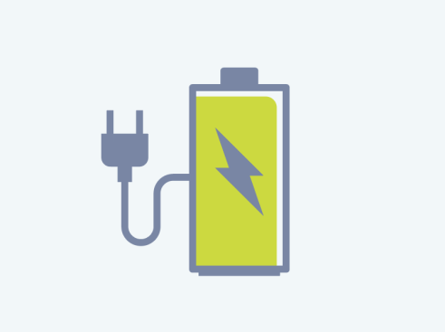
A battery is an energy source consisting of one or more electrochemical cells and terminals on both ends called an anode (-) and a cathode (+). Here for the project, a 3.7V battery has been used.

- Switch:

A switch is used for turning on the power of the vehicle. It controls the battery connection of the vehicle
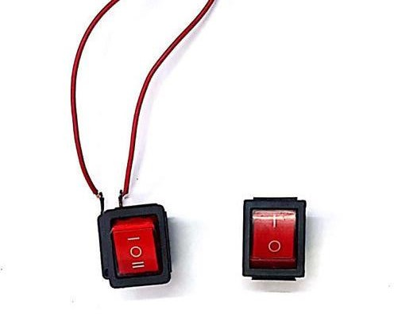

- Bluetooth Module:
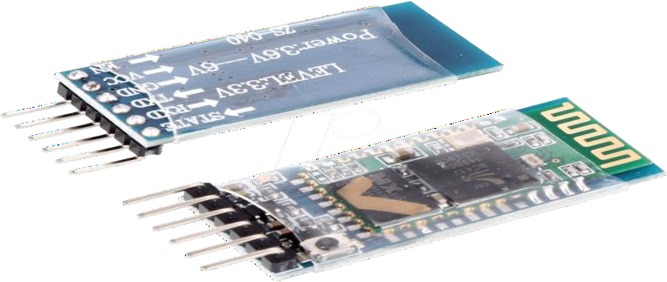
HC-06 6 Pin Wireless Serial Bluetooth Module is a Bluetooth module for use with any microcontroller. It uses the UART protocol to make it easy to send and receive data wirelessly. This means that it can connect to most phones and computers using Bluetooth technology.

- Ultrasonic Sensor:

An ultrasonic sensor is an instrument that measures the distance to an object using ultrasonic sound waves. An ultrasonic sensor uses a transducer to send and receive ultrasonic pulses that relay back information about an object's proximity.

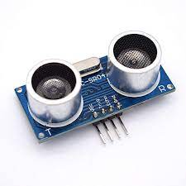
- Servo Motor:

A servo motor is a type of motor that can rotate with great precision. Normally this type of motor consists of a control circuit that provides feedback on the current position of the motor shaft, this feedback allows the servo motors to rotate with great precision. If you want to rotate an object at some specific angles or distance, then you use a servo motor.
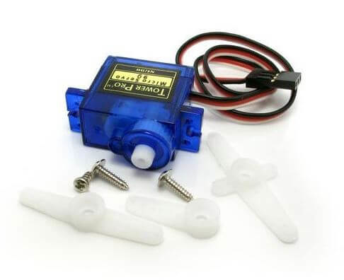

- TP4056 Charging Module:

The TP4056 is a popular lithium-ion battery charging module commonly used for charging single-cell lithium-ion or lithium polymer batteries. It's a compact and cost-effective solution for charging small batteries, and it's widely used in various electronic projects.
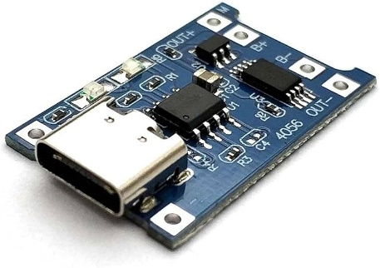
- Solar Panel: (6v)

A solar panel is a device that converts sunlight into electricity by using photovoltaic (PV) cells. PV cells are made of materials that produce excited electrons when exposed to light. The electrons flow through a circuit and produce direct current (DC) electricity, which can be used to power various devices or be stored in batteries.
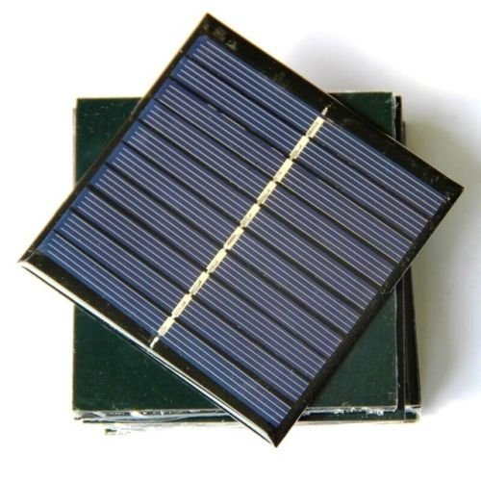
- 18650 Battery Holder:

This 18650-battery cell holder is used to carry/store/keep your lithium ion battery in perfect and safe position. It comes with a single mounting hole in the centre of plastic case which can help us in mounting it on any surface using screws of 3mm.

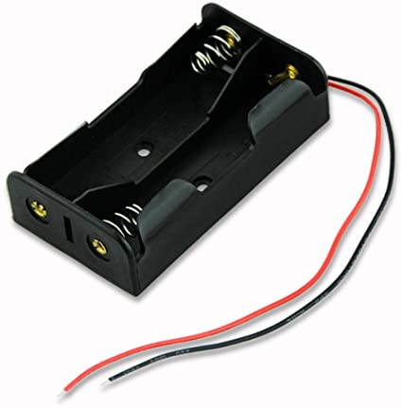
- 5 mm Led:

The 5mm LED can be used anywhere where you need low power, high-intensity reliable light, or indication.

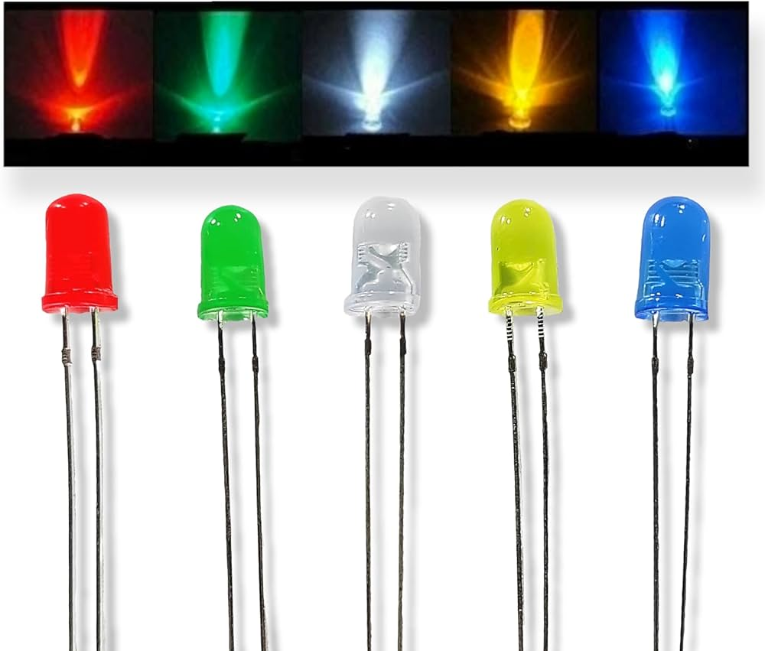

- 1K Resistors:

The value of a resistor is typically measured in Ohms, and the value of a 1K resistor is 1,000 Ohms.

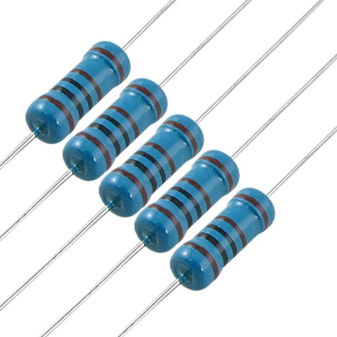
3.2 Pin Diagram & Connection:

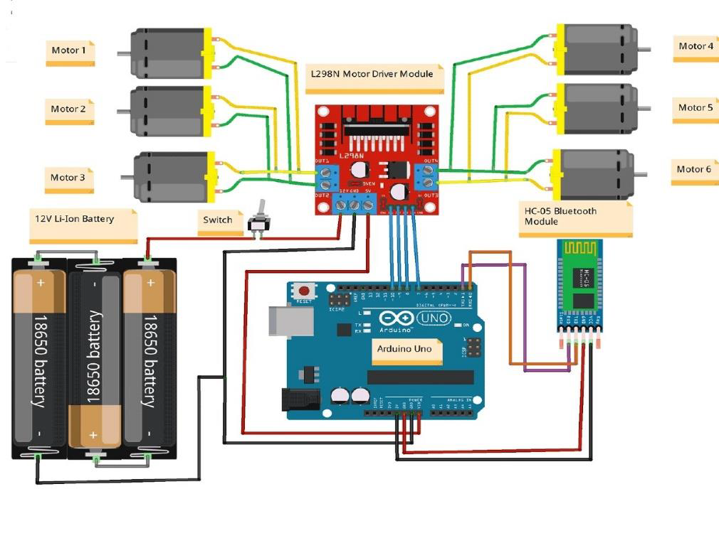

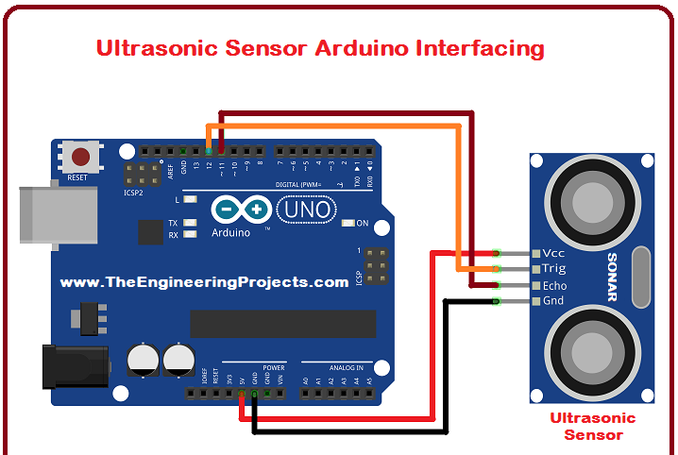

3.3 Source Code:

#include <SoftwareSerial.h>
SoftwareSerial BT_Serial(2, 3); // RX, TX

#include <IRremote.h>
const int RECV_PIN = A5;
IRrecv irrecv(RECV_PIN);
decode_results results;

#define enA 10//Enable1 L298 Pin enA
#define in1 9 //Motor1 L298 Pin in1
#define in2 8 //Motor1 L298 Pin in1
#define in3 7 //Motor2 L298 Pin in1
#define in4 6 //Motor2 L298 Pin in1
#define enB 5 //Enable2 L298 Pin enB

#define servo A4
#define echo A2 //Echo pin
#define trigger A3 //Trigger pin

int distance_L, distance_F = 30, distance_R;
long distance;
int set = 20;

int bt_ir_data; // variable to receive data from the serial port and IRremote
int Speed = 130;
int mode=0;
int IR_data;

void setup(){ // put your setup code here, to run once

pinMode(echo, INPUT );// declare ultrasonic sensor Echo pin as input
pinMode(trigger, OUTPUT); // declare ultrasonic sensor Trigger pin as Output

pinMode(enA, OUTPUT); // declare as output for L298 Pin enA
pinMode(in1, OUTPUT); // declare as output for L298 Pin in1
pinMode(in2, OUTPUT); // declare as output for L298 Pin in2
pinMode(in3, OUTPUT); // declare as output for L298 Pin in3
pinMode(in4, OUTPUT); // declare as output for L298 Pin in4
pinMode(enB, OUTPUT); // declare as output for L298 Pin enB

irrecv.enableIRIn(); // Start the receiver
irrecv.blink13(true);

Serial.begin(9600); // start serial communication at 9600bps
BT_Serial.begin(9600);

pinMode(servo, OUTPUT);

for (int angle = 70; angle <= 140; angle += 5) {
servoPulse(servo, angle); }
for (int angle = 140; angle >= 0; angle -= 5) {
servoPulse(servo, angle); }

for (int angle = 0; angle <= 70; angle += 5) {
servoPulse(servo, angle); }
delay(500);
}

================================================== Obstacle Avoiding Control
========================================================
distance_F = Ultrasonic_read();
Serial.print("S=");Serial.println(distance_F);
if (distance_F > set){forword();}
else{Check_side();}
}

delay(10);
}

long IRremote_data(){
if(results.value==0xFF02FD){IR_data=1;}
else if(results.value==0xFF9867){IR_data=2;}
else if(results.value==0xFFE01F){IR_data=3;}
else if(results.value==0xFF906F){IR_data=4;}
else if(results.value==0xFF629D || results.value==0xFFA857){IR_data=5;}
else if(results.value==0xFF30CF){IR_data=8;}
else if(results.value==0xFF18E7){IR_data=9;}
else if(results.value==0xFF7A85){IR_data=10;}
return IR_data;
}

void servoPulse (int pin, int angle){
int pwm = (angle*11) + 500; // Convert angle to microseconds
digitalWrite(pin, HIGH);
delayMicroseconds(pwm);
digitalWrite(pin, LOW);
delay(50); // Refresh cycle of servo
}

//**********************Ultrasonic_read******************//
long Ultrasonic_read(){
digitalWrite(trigger, LOW);
delayMicroseconds(2);
digitalWrite(trigger, HIGH);
delayMicroseconds(10);
distance = pulseIn (echo, HIGH);
return distance / 29 / 2;
}

void compareDistance(){
if (distance_L > distance_R){
turnLeft();
delay(350);
}
else if (distance_R > distance_L){
turnRight();
delay(350);
}
else{
backword();
delay(300);
turnRight();
delay(600);
}
}

void Check_side(){
Stop();
delay(100);
for (int angle = 70; angle <= 140; angle += 5) {
servoPulse(servo, angle); }
delay(300);
distance_L = Ultrasonic_read();
delay(100);
for (int angle = 140; angle >= 0; angle -= 5) {
servoPulse(servo, angle); }
delay(500);
distance_R = Ultrasonic_read();
delay(100);
for (int angle = 0; angle <= 70; angle += 5) {
servoPulse(servo, angle); }
delay(300);
compareDistance();
}

void forword(){ //forword
digitalWrite(in1, HIGH); //Right Motor forword Pin
digitalWrite(in2, LOW); //Right Motor backword Pin
digitalWrite(in3, LOW); //Left Motor backword Pin
digitalWrite(in4, HIGH); //Left Motor forword Pin
}

void backword(){ //backword
digitalWrite(in1, LOW); //Right Motor forword Pin
digitalWrite(in2, HIGH); //Right Motor backword Pin
digitalWrite(in3, HIGH); //Left Motor backword Pin
digitalWrite(in4, LOW); //Left Motor forword Pin
}
void turnRight(){ //turnRight
digitalWrite(in1, LOW); //Right Motor forword Pin
digitalWrite(in2, HIGH); //Right Motor backword Pin
digitalWrite(in3, LOW); //Left Motor backword Pin
digitalWrite(in4, HIGH); //Left Motor forword Pin
}

void turnLeft(){ //turnLeft
digitalWrite(in1, HIGH); //Right Motor forword Pin
digitalWrite(in2, LOW); //Right Motor backword Pin
digitalWrite(in3, HIGH); //Left Motor backword Pin
digitalWrite(in4, LOW); //Left Motor forword Pin
}

void Stop(){ //stop
digitalWrite(in1, LOW); //Right Motor forword Pin
digitalWrite(in2, LOW); //Right Motor backword Pin
digitalWrite(in3, LOW); //Left Motor backword Pin
digitalWrite(in4, LOW); //Left Motor forword Pin
}

==================================================
Voice Control Command
==================================================
else if(bt_ir_data == 6){turnLeft(); delay(400); bt_ir_data = 5;}
else if(bt_ir_data == 7){turnRight(); delay(400); bt_ir_data = 5;}
}

3.4 Flow Chart of Implementation:

Give command using app and send it through Bluetooth system.
Receive data from the app using Bluetooth module.
Recognize data commands by the microprocessor.
Execute the instructions by controlling the motor drivers.

Chapter-04

Result and Discussion

The prototype is created using 6 DC motors driven by an H-bridge with dual output, connecting the three left wheels and the three right ones to its outputs. The rover is controlled by Bluetooth app. The rover can be using obstacle avoiding using ultrasonic sensor. And the batteries of the rover will be continuously charging using six volts mini solar panel. Some extra functionalities can be added to the software.

Better line tracking mode: When the robot finds an object in front placed on the line, it will try to go around it until it finds the line again, continuing afterward.

Chapter-05

INDIVIDUAL CONTRIBUTION

- D Sree Bhargav Reddy(20201CSE0171), helped in the connections of model & Code.
- M Abhiram Reddy(20201CSE0116)- Assembling the parts, Building the model, helped in coding part.
- Arjun Arun (20201CSE0134)- Preparation of ppt for review 2, helped in connections of model, helped in preparing report.
- B Sravan Kumar Reddy(20201CSE0133)- Helped in the preparation of ppt, report, and code.
- K Babu(20201CSE0171) -Helped in the preparation of ppt, report, code.

Chapter-06

Conclusion

This project consists of a basic prototype of a Bluetooth and Voice control Rover above stated. The prototype car can recognize commands from users and can turn the car left, right, and stop with great accuracy. It can be further improved by using different sensors like ultrasonic and with various levels of coding.

Our Rover has a range of 10-20 meter with the mobile Bluetooth controlling system. The range mostly depends on the receiver’s transmission level.

Also, we could make use of this RC Motor Car as a surveillance system or rovers by adding a few more sensors and updating the code. This would make them into robots. These robots could self-monitor under any human supervision, thereby reducing manpower. These are just the alternatives, on which this project could be improvised and updated.

IoT or the internet of things is a very important part of both computers and our daily lives. The above model describes how the Arduino programs the rover motor module and by IoT, we rotate the wheels and give direction to the rover. IoT allows us to work with different platforms and it helps us to create various interesting modules to work on.

With the ever-increasing problems, our knowledge has to expand to adapt better to the changes all around us. In the same way, it is hoped that this activity is a small step that would lead us to further enhancements and goals.

References:

- Wang, B.Y. (2009) Summary of IoT Technology Research. Journal of Electronic Measurement and Instrument, 12, 1-7.

- J. Gubbi, R. Buyya, S. Marusic, M. Palaniswami, Internet of things (IoT): a vision architectural elements and future directions, Future Gener. Comput. Syst. 29 (7) (Sep. 2013) 1645–1660.

- Ibrahim, D. Ibrahim, Real-time GPS-based outdoor WiFi localization system with map display, Adv. Eng. Softw. 41 (2010) 1080–1086.

